PIZZA SALES SQL QUERIES
A.KPI’S:
1.TOTAL REVENUE:
- select sum(total_price) as Total_revenue from [pizza info]
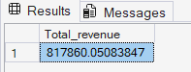
2.Average order value:
- select sum(total_price)/count(distinct(order_id)) as Average_order_value from [pizza info]
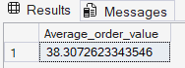
3.Total pizzas sold:
- select sum(quantity) as Total_pizzas_sold from [pizza info]
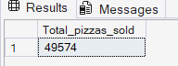
4.Total orders:
- select count(distinct order_id) as Total_orders from [pizza info]
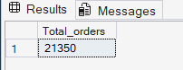
5.Average pizzas per order:
- select sum(quantity)/count(distinct order_id) as Avg_pizzas_per_order from [pizza info]
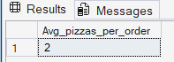
B.Daily trend for Total orders:
- select datename(dw,order_date) as order_day,count(distinct order_id) as total_orders from [pizza info] group by datename(dw,order_date)
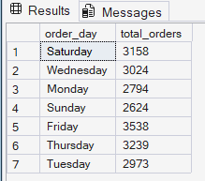
C.Hourly trend for Total orders:
- select datepart(hh,order_time) as order_time,count(distinct order_id) as total_orders_hourly from [pizza info] group by datepart(hh,order_time) order by datepart(hh,order_time)
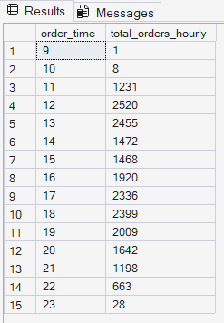

D.Percentage of sales by pizza category:
- select pizza_category,sum(total_price)*100/(select sum(total_price) from [pizza info]) as PCT from [pizza info] group by pizza_category
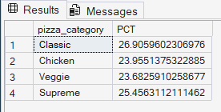
E. Percentage of sales by pizza size:
- select pizza_size,sum(total_price)*100/(select sum(total_price) from [pizza info]) as PCT from [pizza info] group by pizza_size
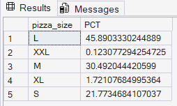
F.Total pizzas sold by pizza category:
- select pizza_category,sum(quantity) as Total_pizzas_sold from [pizza info] group by pizza_category
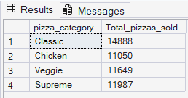
G.Top 5 best sellers by total pizzas sold:
- select top 5 pizza_name,sum(quantity) as total_solds from [pizza info] group by pizza_name order by sum(quantity) desc
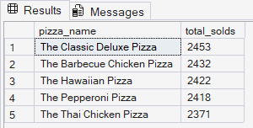
H.Bottom 5 worst sellers by total pizzas sold:
- select top 5 pizza_name,sum(quantity) as total_solds from [pizza info] group by pizza_name order by sum(quantity)
